***Business Reason***

. In order to properly align the proposal and invoice with regards to price and charge codes Capture will specify a DEL and REM for exchanges (ie customer wishing to move from and 6 to and 8 yard container).

***Task Requirements***

* Remove the EXC charge code from the line item grid
* Add charge codes REM and DEL to line item grid.
* Zero out the REM price, but keep the floor/avg/target **(issuing a credit)**
* Keep the standard DEL charge
* Both prices should be editable by the sales rep
* CSA will display credits for REM and DEL in comments section as the EXC currently does
* Proposal, display both charge codes with associated credits as normally would. (See screen shot below)
* Scenario will only be triggered for existing customers when a service change is specified and the size of the container has changed
* Will need to specify Removal discount in CSA

***Build Plan***

1. Change Service Change Recommended Item Rule to no longer add exchange parts and instead add removal and delivery
   1. Change reccomendedItemRuleForServiceChangeNew recommended item rule under the Service Change configurator to add REM and DEL parts instead of an EXC part, and additionally use the old and new quantities for those parts respectively:

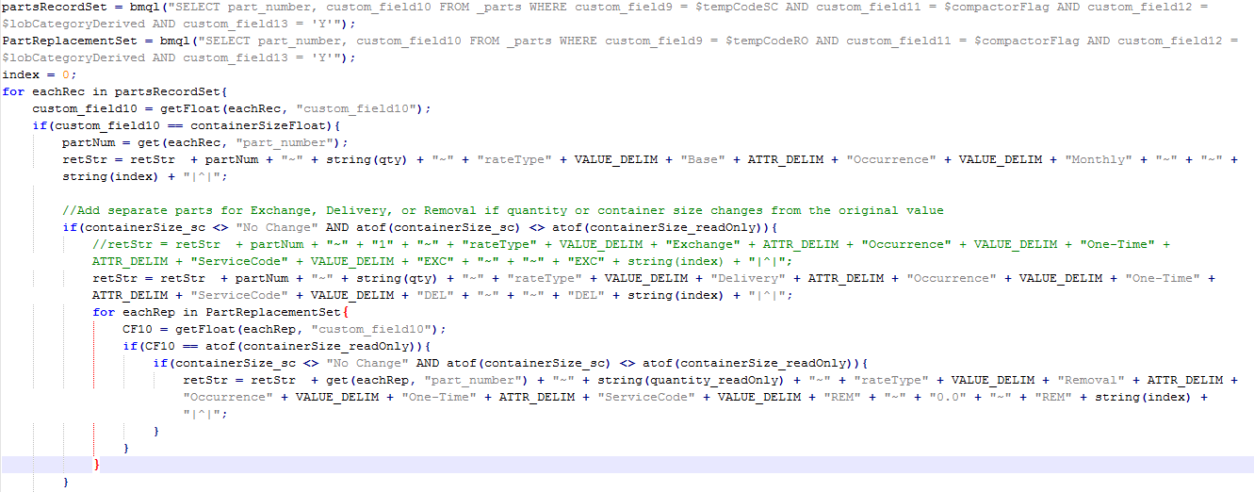

1. Change the Removal cost and price to $0.00
   1. Change is PrePricingFormulas commerce util formula to force set removal cost to $0.00

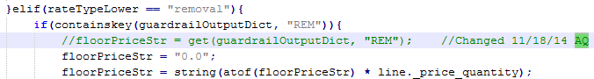

* 1. Change the post formula modify function to set the price for removal to $0.00

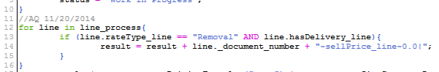

1. CSA will display credits for REM and DEL in comments section as the EXC currently does
   1. Change in postPricingFormulas commerce util to calculate the credit

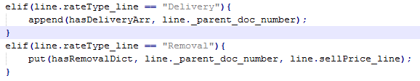

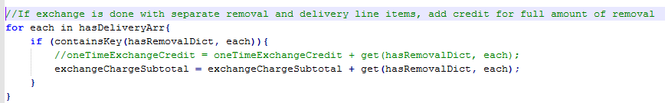

* 1. Change commentsForDeliveryAndExchangeCretOnOutput util to accurately reflect the size of the containers being removed:

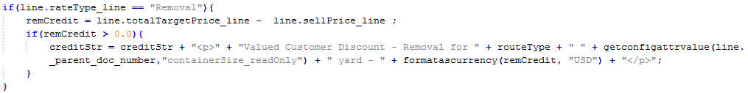

* 1. Added commerce line level attribute to store per unit price for delivery, divisionDeliery_ui_line
  2. Add calculation to prePricingFormulas to get a per unit price for delivery

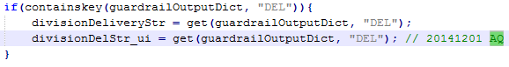

* 1. Edited the CSA DocEngine document to use the new attribute on the CSAItems page:

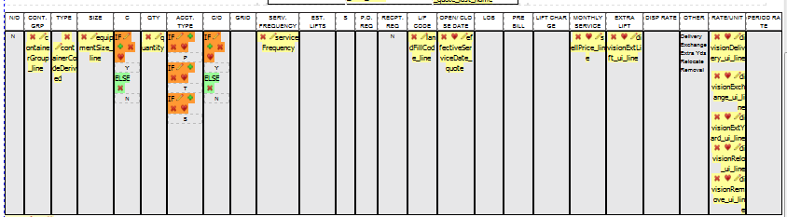



***Admin Guide Changes***

***User Guide Changes***